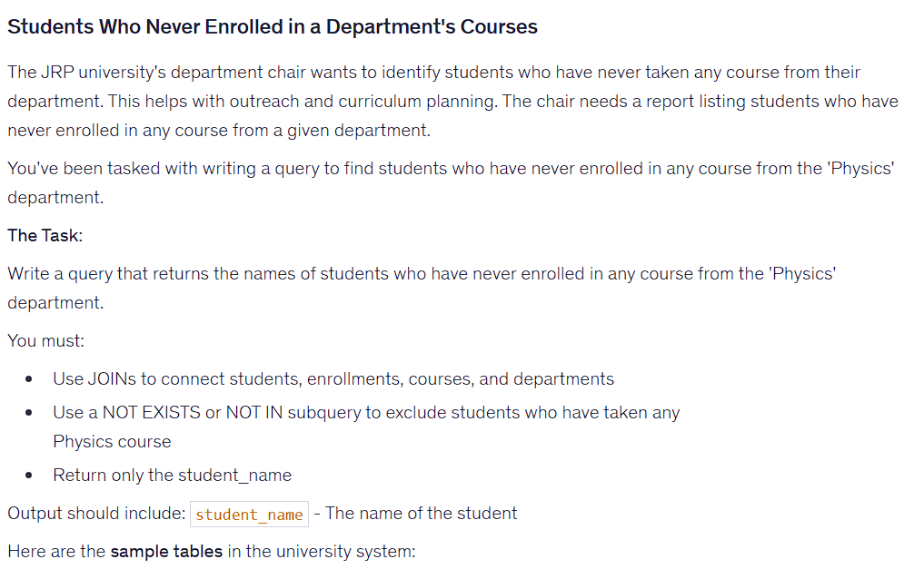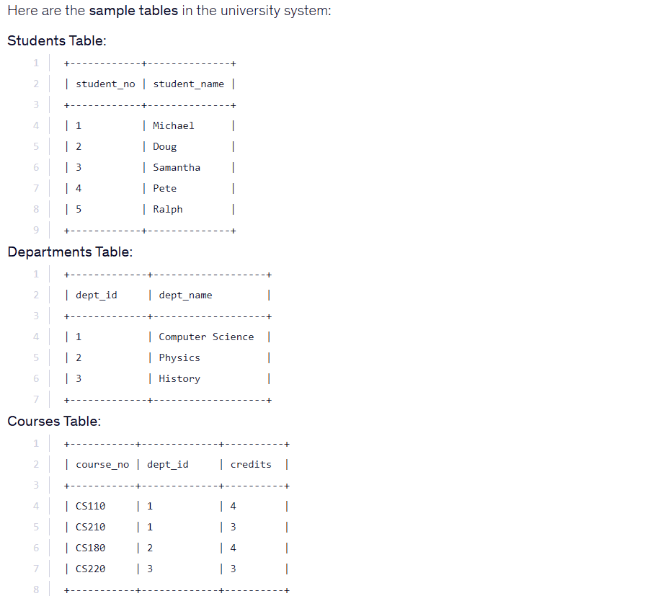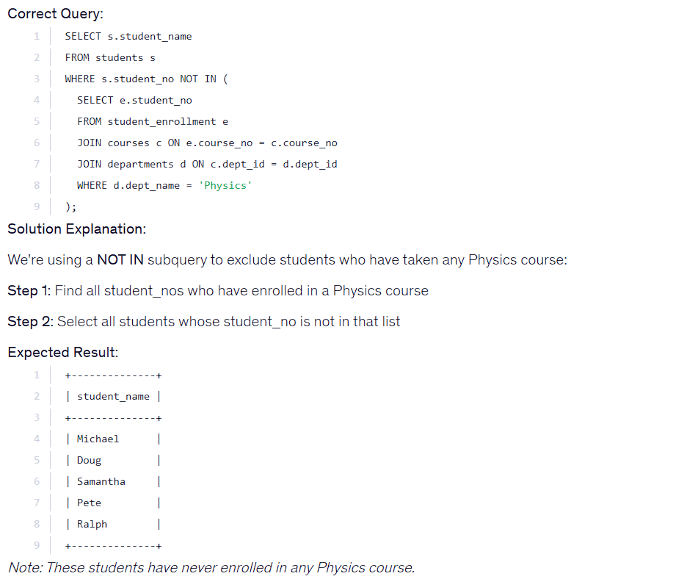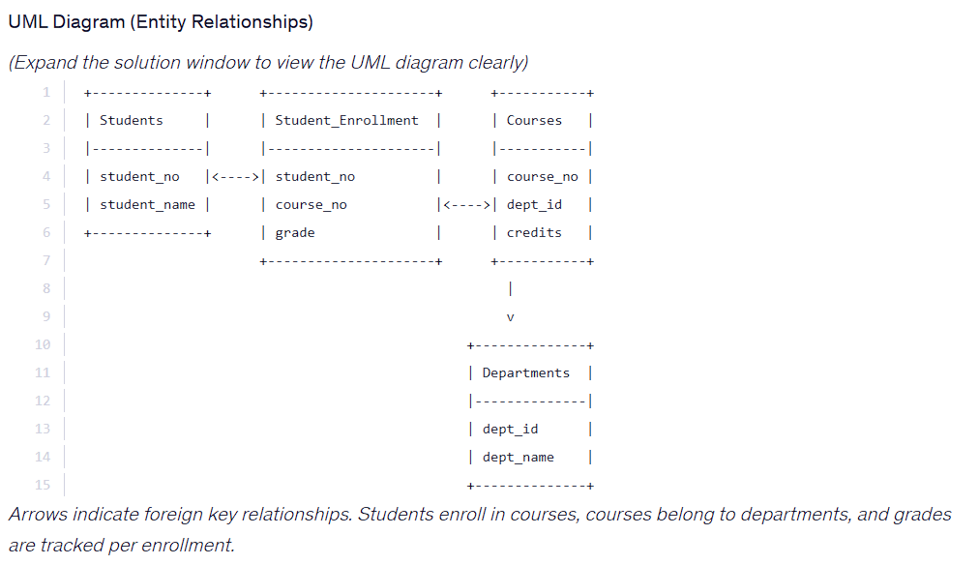

SELECT s.student_name
FROM students s
WHERE s.student_no NOT IN (
SELECT e.student_no
FROM student_enrollment e
JOIN courses c ON e.course_no = c.course_no
JOIN departments d ON c.dept_id = d.dept_id
WHERE d.dept_name = 'Physics'
);

